Technical Architecture:

Project Design Phase-II Technology Stack (Architecture & Stack)

|  |  |
| --- | --- |
| Date | 15 October 2022 |
| Team ID | PNT2022TMID51330 |
| Project Name | Digital Naturalist - AI Enabled tool for Biodiversity Researchers |
| Maximum Marks | 4 Marks |

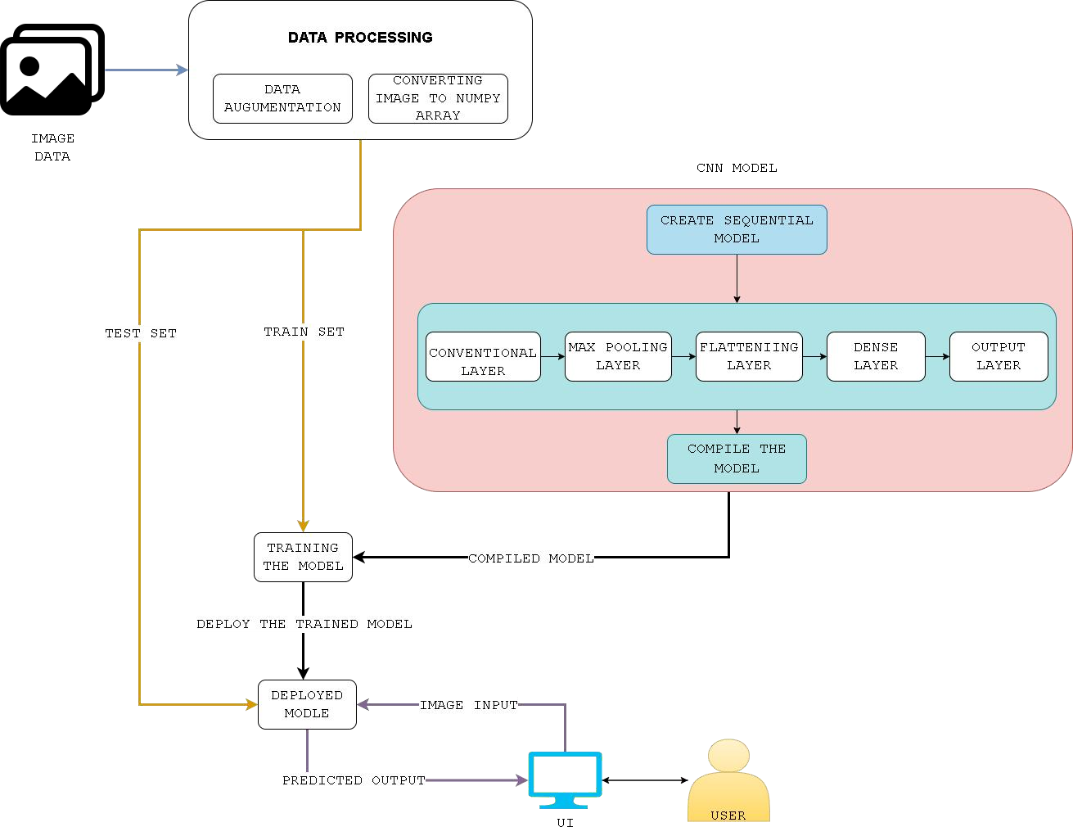

Table-1 : Components & Technologies:

|  |  |  |  |
| --- | --- | --- | --- |
| **S.No** | **Component** | **Description** | **Technology** |
| 1. | User Interface | Web UI or Website. | HTML, CSS, JavaScript |
| 2. | Application Logic-1 | Image upload | Java / Python |
| 3. | Application Logic-2 | Display search Result. | Python, HTML, Flask, IBM Cloud |
| 4. | Image Recognition Model | To predict the species through the image provided | CNN |
| 5. | Infrastructure (Server/Cloud) | Application Deployed on cloud server | IBM Cloud |

Table-2: Application Characteristics:

|  |  |  |  |
| --- | --- | --- | --- |
| **S.No** | **Characteristics** | **Description** | **Technology** |
| 1. | Open-Source Frameworks | Open-Source frameworks for data preprocessing, web application and model training | Keras, Python Flask, Tensorflow, CNN, scikit-learn and matplotlib. |
| 2. | Security Implementations | Capacity of the application to handle growth, especially in handling more users. | IBM Cloud |
| 3. | Availability | Without near 100% availability, application reliability and the user satisfaction will affect the solution. | IBM Cloud |
| 4. | Performance | How the application is functioning and how responsive the application is to the end-users depending on the performance of IBM cloud platform. | IBM Cloud |